|  |  |
| --- | --- |
|  | **HEMDALL VCS**  **(Vehicle Counting System)**  **Setup Guide**  Dígame Systems  88 E. San Fernando St. Suite 1511  San Jose, CA 95113   |

Trademarks

Dígame is a trademark of Dígame Sytems. Microsoft, Windows, and Windows NT are registered trademarks of Microsoft Corporation. Other brand and product names are registered trademarks or trademarks of their respective holders.

Statement of Conditions

In the interest of improving internal design, operational function, and/or reliability, Dígame reserves the right to make changes to the products described in this document without notice. Dígame does not assume any liability that may occur due to the use or application of the product(s) or circuit layout(s) described herein.

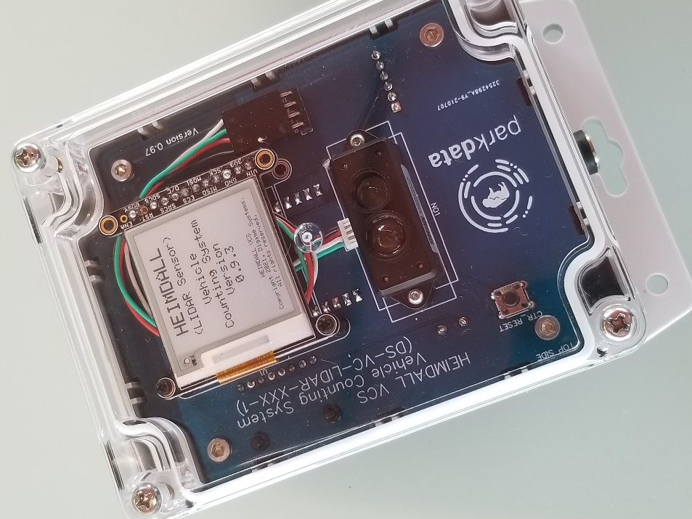

# Introduction

Thank you for your purchase!

The HEIMDALL VCS is an easy-to-deploy, state-of-the-art vehicle tracking system that provides fast, reliable traffic data for your application.

TODO: -- Put a blub here describing the collaboration between Dígame and the Parkdata project.

Unlike other vehicle counting technologies like loop sensors that require cutting up the roadway, HEIMDALL VCS is deployed roadside and never touches the road surface. This not only makes installation simple but saves on maintenance costs and reduces traffic disruptions.

The key is the sensing technology – LIDAR. The same technology used in some self-driving cars.

Vehicle counting sensors are deployed roadside and use an invisible laser to measure the distance from the sensor to any object in front of it up to 100 times per second. When a vehicle passes in front of the sensor, a characteristic “signature” is generated that the sensor uses to determine that a traffic event has occurred.

Vehicle events are transmitted wirelessly using a long-range RF link (LoRa) to a network base station that forwards the information to the ***Parkdata*** cloud service.

After a quick initial configuration, all of this happens automatically. Count events simply show up in the ***Parkdata*** dashboard.

Let’s get started.

# System Components

HEIMDAL VCS consists of several components that work together to feed data to the Parkdata system.

* ***A Solar Power System***: Traffic Counters are powered by a rechargeable lithium-ion battery pack which is maintained by a 10 Watt solar panel. Both the panel and battery packs are weatherproof and designed to be mounted outdoors, near the sensor.
* ***One or more LIDAR Vehicle Counters***: Vehicle counters are typically mounted on a post roadside pointing across traffic. The LIDAR sensor is placed at a height of about one meter above the road’s surface so the laser can easily detect most vehicles. Detection parameters for the LIDAR “signature” algorithm may be easily adjusted at setup using a cell phone.
* ***One or more LoRa / WiFi Base Stations:*** Base station units are designed to collect data from multiple Vehicle Counters and forward events to the Parkdata system over your WiFi network. The base station and the counters communicate using a long-range wireless protocol (LoRa) with a line-of-sight range of over a kilometer. – The reliable range of the system is a function of both environmental factors (hills, trees, walls, etc.) and LoRa transmission parameters. These parameters can be adjusted through the base station’s web user interface.

**Block Diagram:**

LoRa

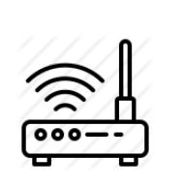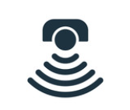

***Parkdata***

WiFi

LIDAR

Solar

Base

Station

# Setting up the System

## Hardware

For our two-counter system, in the box you should find:

* Two (2) Vehicle Counters with LIDAR sensor and eInk display.
* Two (2) Battery Pack modules.
* One (1) Base Station unit with eInk display.
* Two (2) Voltaic Systems 10-Watt Solar Panels. (<https://voltaicsystems.com/10-watt-panel-etfe/>)
* Two (2) Solar Panel Mounting Brackets. (https://voltaicsystems.com/bracket/)
* Two (2) Waterproof solar panel extension cables/adapters for the battery packs.
* Two (2) 3’ DC power cables to power the counters when the battery pack needs to be placed some distance from the counter.
* Two (2) 1.5’ DC power cables to power the counters when the battery pack can be mounted closer to the counter.
* One (1) USB to DC power cable to power the base station.
* One (1) USB to waterproof connector for charging the battery pack on USB.
* One (1) USB power plug to power the base station.

### **TODO:** Detailed setup pictures of connectors / mounting, solar panels, battery packs. – Instructions on ‘gotchas’ we find.

South

1 Meter

### Notes

Solar panels should be mounted to face South to achieve the best efficiency throughout the day.

Connect the battery packs to the solar panels using the extension / adapter cable with the blue waterproof connector.

The fit of the black connector to the solar panel cable is tight. You should feel a click when the two are properly engaged.

The blue end screws into the corresponding connector on the battery pack. – There is a white alignment mark on both connectors. Tighten the connector in place to finger tightness to achieve a watertight seal.

Battery packs should be mounted with the connections facing down and mounted in the shade of the solar panel, if possible.

The Vehicle Counters should be mounted to point across the flow of traffic near the side of the roadway with the power connector pointing down. The black, LIDAR sensor should be mounted at a height of about 1 meter above the road surface.

The default threshold for detection is 3 meters from the sensor. If the installation requires the sensor be placed farther than this from where the vehicles pass, this parameter can be adjusted. (See below)

The base station unit should be placed indoors, preferably near a window within range of your WiFi router. The higher the base station can be placed, the better. (Ground effects can negatively influence range.) If possible, orient the base station unit vertically, so the orientation of the base station matches that of the counters.

## Software / Firmware

When working with the Vehicle Counters and the Base Stations, it is important to understand the difference between two modes wireless devices can support: ***Access Point Mode***and***Station Mode***.

* ***Station Mode:*** Is what a laptop computer, a printer or our Base Station units normally use. In this mode, the device connects to the local wireless router and the router provides internet access. To make the connection, the device needs to know the SSID and Password for the local network.

How do we load these parameters into the Base Station for a new installation? This is where Access Point Mode comes in.

* ***Access Point (AP) Mode:*** In Access Point Mode, a device acts like a tiny router and creates its own wireless LAN to which other devices can connect. (There is no access to the greater Internet in this mode.) Both the Vehicle Counters and Base Station units can be put into Access Point Mode by holding down the CTR_RST button on the board during the boot process. – An un-configured Base Station unit will come up in AP mode by default.

When the devices come up in AP mode, they display their SSID and IP address on the eInk display and start up a small web server for configuration.

### AP Mode Configuration

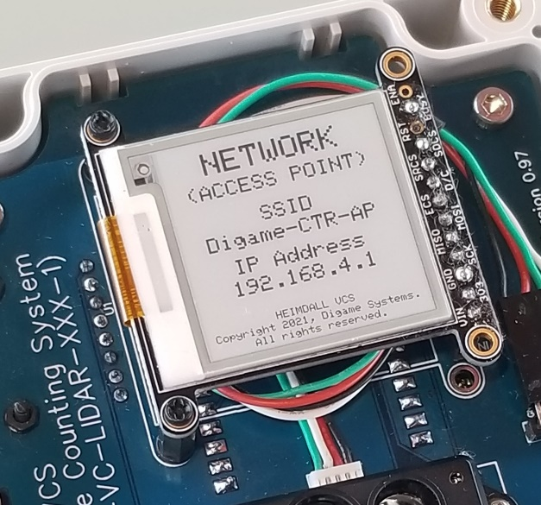When the Base Station or Vehicle Counter is booted into AP Mode the eInk display will look something like this:

SSIDs:

Base Station **Dígame -STN-AP**

Counter **Dígame -CTR-AP**

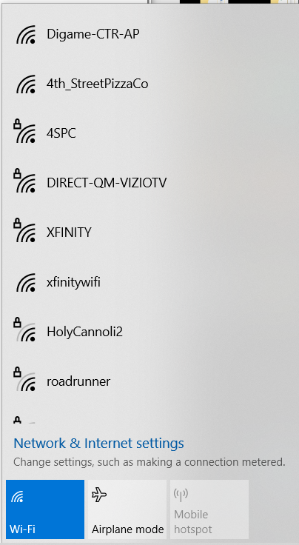Open your network settings on either your laptop or phone and click on the SSID to connect.

You may get a message that the internet is unavailable. – This is normal. AP Mode is a strictly local network.

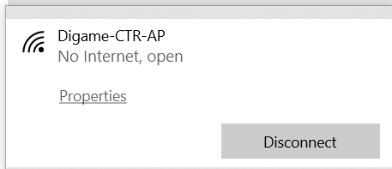

### The Web User Interface

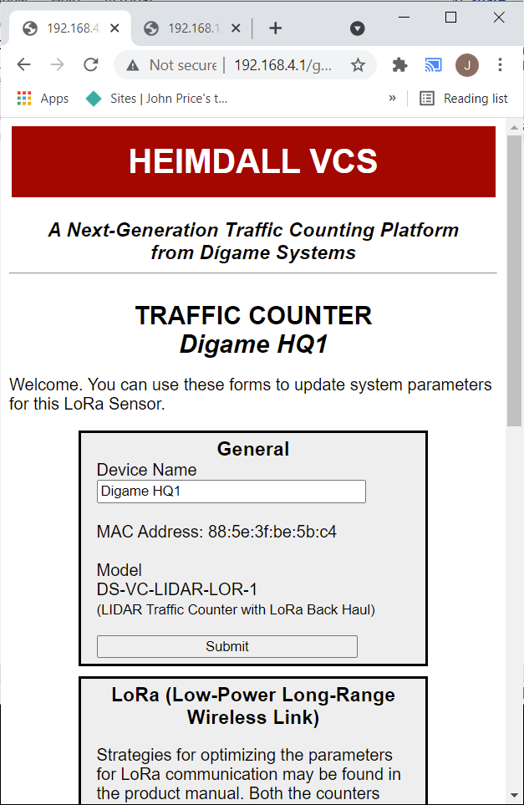From your browser, now navigate to the IP address shown on the eInk display. (192.168.4.1) You will be presented with a simple device configuration interface.

Changes made here will be saved to device memory and applied on the next boot.

Parameters are described below.

### General

Both Vehicle Counters and Base Stations have a section that allows you to set the device name and inspect the device’s MAC address and Model Number.

### LoRa

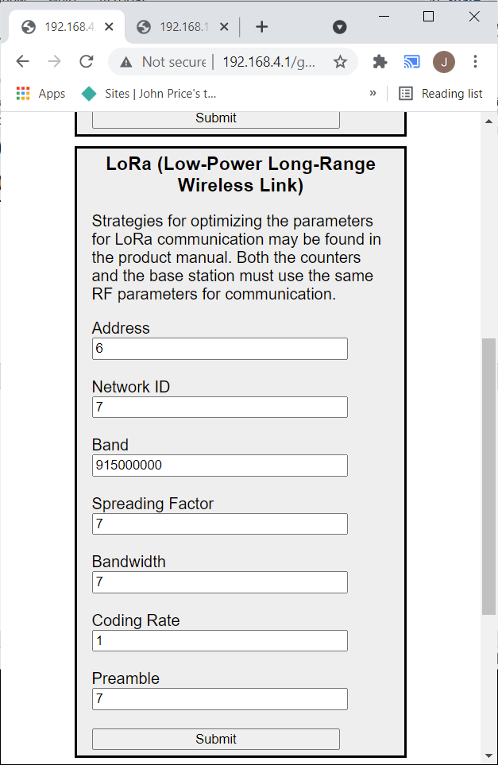The LoRa radio link requires that the base station and vehicle counters both have the same settings for key RF parameters.

These settings can be changed to optimize link reliability and data throughput, but they must be the same on each end of the RF link. In most cases, the default settings should work well and the only thing that might need to be changed for a counter is its Address field.

**Address**: Base Stations are given the address of 1. It is recommended that all counters be given a unique address so that the base station can distinguish between them. Address 0 is a special address that broadcasts to all listeners.

**Network ID**: Devices can only communicate with each other if they have the same Network ID. This allows multiple base stations to work in the same area.

**Spreading Factor**: A parameter related to the time it takes to transmit data and the range the data can be sent reliably. Larger spreading factors take longer to send but can send information over longer distances. Smaller spreading factors transmit data more quickly, but less reliably. Valid range is 7-12.

**Bandwidth**: Related to how quickly bits are transmitted for a given Spreading Factor. The default value of 7 (125 kHz) should be sufficient for most applications.

**Band**: The frequency (in Hz) of the RF transmissions. In cases where there is single frequency interference, this may be changed.

**Coding Rate**: Smaller values result in faster transmission.

**Preamble**: A series of transitions at the start of a message that helps the radios synchronize. Higher values are more reliable but take longer to transmit. (Should rarely need to be changed.)

### LIDAR Parameters

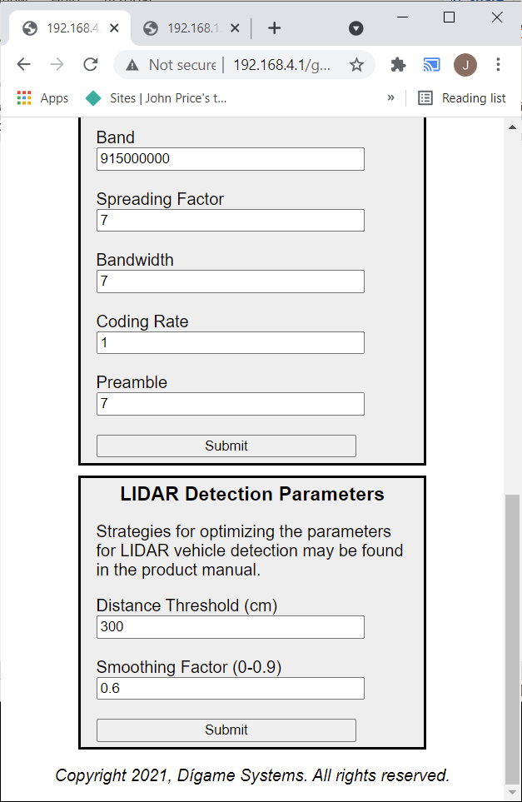For Vehicle Counters, two parameters can be tuned to optimize performance.

**Distance Threshold (cm):** If the LIDAR sensor detects an object inside this distance, it will count as “present”. Once the object moves beyond this threshold (or leaves the area) the logic transitions to “absent”

An “absent” to “present” to “absent” sequence counts as a vehicle event and is reported to the system.

This parameter can be adjusted from the default value of 3 meters if a lane is especially wide.

**Smoothing Factor**: LIDAR data can be collected at speeds of up to 100 measurements per second. This term provides the option to adjust the amount of averaging that is done on the raw data to smooth out spurious noise coming from complex structures on a target.

Larger smoothing factors can slow system response and can lead to missing fast moving vehicles. Adjust this parameter with caution.

### Sensors

A Base Station can route data from multiple Vehicle Counters. (Current firmware supports 4.)

When a message comes in from a Counter, the device address is used to look up the sensor name and MAC address to be reported to the Parkdata system.

When configuring a new system, first note the MAC addresses and LoRa address for the counter (it is on a label on the back of the counters) and then enter them into the configuration interface on the Base Station.

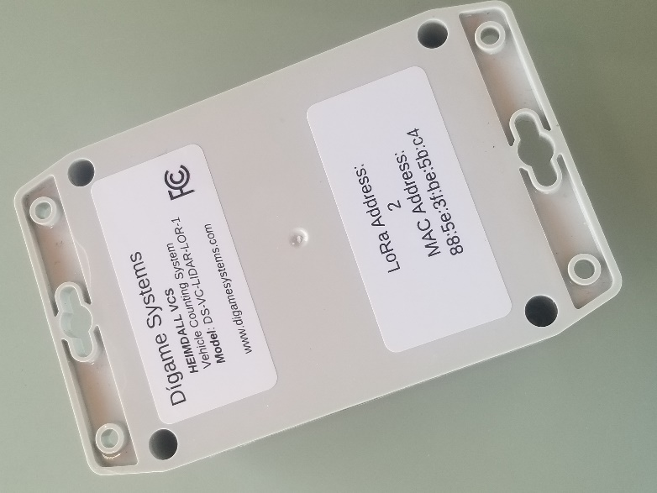

Counters broadcasting with addresses unknown to the base station will not be reported.

## Operation / Maintenance

On power up, both the Counters and the Base Station will cycle through a series of screens, starting with a ‘splash’ screen that shows the current firmware version running on the device.

For Counters, the device will execute a series of Self-Test functions to verify the operation of the hardware.

If successful, a second screen will appear, indicating each system is functioning properly.

After the self-test, the Counter will issue a ‘boot’ message over the LoRa link, telling the Base Station that it has started, activate the LIDAR module, and begin looking for Vehicles. A screen showing the total number of counts since the system was booted is shown that is dynamically updated in real time.

This screen is especially useful during setup to verify correct operation.

After setup, the total count can be reset to zero by pressing the button on the PCB labeled “CTR_RESET”.

### **TODO:** Add screens for Base Station Unit and describe Show a typical setup in an office environment?

### Maybe a picture of typical range observed for the default conditions?

## Troubleshooting

TBD

## Regulatory

FCC Statement:

This device complies with part 15 of the FCC Rules.

Operation is subject to the following two conditions: (1) This device may not cause harmful interference, and (2) this device must accept any interference received, including interference that may cause undesired operation.

NOTE: This equipment has been tested and found to comply with the limits for a Class B digital device, pursuant to part 15 of the FCC Rules.

These limits are designed to provide reasonable protection against harmful interference in a residential installation. This equipment generates, uses and can radiate radio frequency energy and, if not installed and used in accordance with the instructions, may cause harmful interference to radio communications. However, there is no guarantee that interference will not occur in a particular installation. If this equipment does cause harmful interference to radio or television reception, which can be determined by turning the equipment off and on, the user is encouraged to try to correct the interference by one or more of the following measures:

* Reorient or relocate the receiving antenna.
* Increase the separation between the equipment and receiver.
* Connect the equipment into an outlet on a circuit different from that to which the receiver is connected.
* Consult the dealer or an experienced radio/TV technician for help.

Changes or modifications not expressly approved by the party responsible for compliance could void the user’s authority to operate the equipment.

This unit contains:

FCC ID QLYRYLR896

FCC ID 2AC7Z-ESPWROOM32.

Appendix A - Technical Specifications

Use Case

• Vehicle counting applications: 1-2 Lanes of traffic.

• Vehicle speed: up to 60 MPH

LIDAR Sensor Specifications

• Operating Range: 0.1 – 12 meters

• Accuracy: +/- 5 cm

• Field of View: 3.6 degrees

• Frame Rate: 100 Hz

• Counting Accuracy: >99% counting accuracy at distances < 10 meters and speeds < 60 mph. (Performance may vary in extreme weather conditions.)

Interface / Communications

• WiFi, LoRaWan (with accessory gateway)

• Cellular service: Not included.

• Security: HTTPs, WPA under WiFI

• API: JSON-based for easy integration

Mounting / Power

• Mounting: Surface mount or pole mount (custom options available)

• Input Voltage: 5-7 VDC (DC power supply or supplied solar panel output)

• Power Consumption: < 0.5 Watts typ.

• Battery: Capacity 12,800mAh, 47 Watt Hours

• Battery Type: Li-Ion

• Protection: Short circuit over charge, over discharge, over temperature (45°Input Cutoff, 60° Output Cutoff), under temperature (0° Input Cutoff, -20° Output Cutoff)

Environmental

• Enclosure: High Impact UV resistant polycarbonate, IP67/NEMA4.

• Operational Temperature: -20℃ to +45℃

• Storage Temperature: -20°C to +60°C

• Warranty: Replacement, 3 years parts and labor.

Appendix B - Related Documents

TBD